New Mexico Bureau of Geology & Mineral Resources
A DIVISION OF
NEW MEXICO INSTITUTE OF MINING & TECHNOLOGY
801 Leroy Place
Socorro, NM 87801-4796

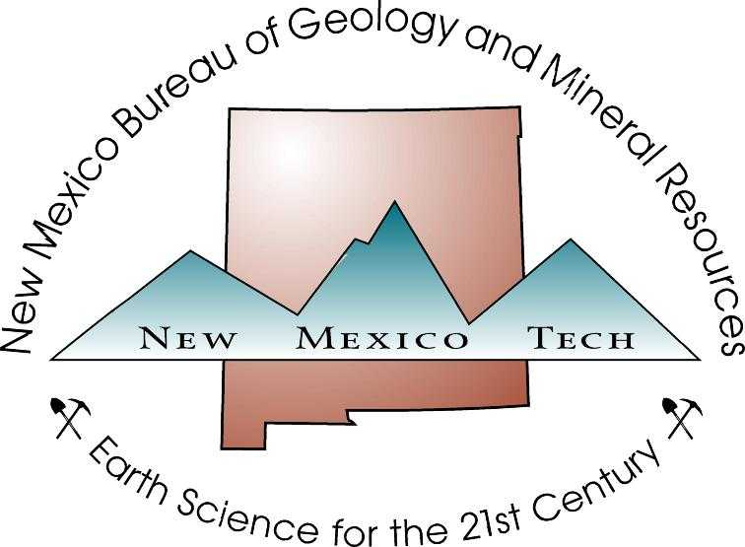

PERMISSION TO POST MY THESIS OR DISSERTATION ON THE BUREAU WEBSITE

I, , give permission to the New Mexico Bureau of Geology and Mineral Resources (Nelia Dunbar, Director), New Mexico Institute of Mining and Technology, 801 Leroy Place, Socorro, New Mexico 87801-4796, to post my thesis or dissertation, as provided to the Bureau by the New Mexico Tech Joseph R. Skeen Library, on the Bureau website.
- A copy of my thesis or dissertation may be archived in the Bureau’s Geologic Information Center and will be available to the public for viewing.
- I understand that I retain the copyright of the thesis and that I may request that the posted materials be removed from the website at any time for any reason.

Signed: ___________________________________________________

Dated: ___________________________________________________

