PETROGRAPHIC, MINERALOGICAL AND CHEMICAL CHARACTERIZATION OF GOATHILL NORTH MINE ROCK PILE, QUESTA MOLYBDENUM MINE, QUESTA, NEW MEXICO¹
Virginia T. McLemore², ginger@gis.nmt.edu. Kelly Donahue, Erin Phillips, Nelia Dunbar, Mike Smith, Samuel Tachie-Menson, Vanesssa Viterbo, Virgil W. Lueth, and Andrew R. Campbell

Abstract. Rarely do rock pile characterization studies allow for petrographic, mineralogical, and geochemical characterization of the undisturbed interior of large rock piles in-situ. The regrading of the stable portion of Goathill North (GHN) rock pile at the Molycorp Questa molybdenum mine, New Mexico, provided an opportunity to examine and sample rock pile material in-situ through the construction of trenches cut into the rock pile as earth-moving progressed. Maps of each bench were created to describe the different stratigraphic units, including the thickness, dip, and extent of the units. Units were defined based on grain size, color, texture, stratigraphic position, and other physical properties that could be determined in the field. Units were correlated between benches and to both sides of each trench, and several units were correlated downward through the excavated trenches in the rock pile. Characterization of original rock pile material was accomplished by petrographic, mineralogic, and chemical analysis and includes descriptions of rock fragment lithology, mineralogy, texture, and alteration type and intensity. Rock fragment lithology is generally consistent within mapped units and correlates well with mineralogy and chemistry. Typically, paste pH and carbonate abundance increases with distance from the outer, oxidized zone (west) towards the interior, unoxidized zone (east) of the GHN rock pile. Conversely, authigenic gypsum, which is likely a product of in-situ weathering, usually exhibits a decrease in abundance from the outer to the inner portion of the rock pile. CaO and Sr also typically increase in concentration from the outer, oxidized zone (west) towards the interior, unoxidized zone (east) of the GHN rock pile, suggesting dissolution of feldspars and calcite to form gypsum in the outer, oxidized portions of the rock pile. Clay mineral and electron microprobe analyses of soil samples and unweathered drill core imply that the majority of clay minerals in the GHN samples are derived from the original pre-mining hydrothermal alteration and not by oxidation of minerals within the rock pile.
Additional key words: weathering study, Taos County, Molycorp, waste rock piles, sulfide oxidation
_____________________________
¹ Paper was presented at the 2006 Billings Land Reclamation Symposium, June, 2006, Billings, Mt. Published by ASMR, 3134 Montavesta Rd., Lexington, KY 40502.
²Virginia T. McLemore, PhD, Senior Economic Geologist/Minerals Outreach Liaison, New Mexico Bureau of Geology and Mineral Resources (NMBGMR), New Mexico Institute of Mining and Technology (NMIMT), Socorro, NM 87801, ginger@gis.nmt.edu. Kelly Donahue, Erin Phillips, Mike Smith, Geological Associates, NMBGMR. Nelia Dunbar, PhD, Assistant Director/Geochemist for NMBGMR. Samuel Tachie-Menson, Vanesssa Viterbo graduate students, Mineral Engineering Department, NMIMT. Virgil Lueth, PhD, Senior Mineralogist/Economic Geologist, NMBGMR. Andrew Campbell, PhD, Professor, Earth and Environmental Science Dept at NMIMT.

Introduction

Purpose
Rock piles, the preferred term by many in the metal mining industry today, refer to the man-made structures consisting of piles of non-ore material that had to be removed in order to extract ore. This material, referred to in older literature as mine waste, mine soils, overburden, subore, or proto-ore, does not include the tailings material, which consists of non-ore material remaining after milling.
Geologic, mineralogical, and chemical characterization of mine rock piles with depth is important to (1) characterize pre-mining background conditions (Briggs et al., 2003), (2) to characterize and predict stability and erosion (Dawson, 1994; URS Corporation, 2000), (3) to predict acid-rock drainage (McLemore et al., 2004b, Shaw et al., 2002), (4) to properly dispose of and manage mine overburden (Dawson, 1994), and (5) to develop mine closure plans (URS Corporation, 2000; Wels et al., 2002). Most site characterizations of rock piles are based upon (1) drilling of the rock piles (Robertson GeoConsultants, Inc. 2000a, b; URS Corporation, 2000), (2) shallow surface test pits (URS Corporation, 2000), or (3) composite surface sampling (Smith et al., 2000a, b; Munroe and McLemore, 1999, 2000; Briggs et al., 2003; Wildeman, 2003). Rarely do these methods of site characterization allow for examination, mapping, and sampling of the interior of large rock piles in-situ. Examination of the interior of two mine rock piles during removal was described by Fines et al. (2003) and Tran et al. (2003) who documented complex dipping layers within the rock piles. Most other studies of mine rock piles have involved drilling, surface test pits, and numerical modeling.
The regrading of the stable portion of the Goathill North (GHN) rock pile at the Molycorp Questa molybdenum mine, Taos County, New Mexico, provided a rare opportunity to examine, map, sample, and develop a conceptual model of the interior of a large mine rock pile in situ by means of trenches cut into the rock pile. The purpose of this report is to describe the mineralogical and chemical laboratory results of trench sampling within the interior of the stable portion of the GHN rock pile. The sampling techniques employed in this study differ from most studies because of the construction of wide trenches downslope through the rock pile as regrading progressed (McLemore et al., 2005, 2006).

Investigation approach
The purpose of the Molycorp weathering study is to develop a model to identify and assess conditions and processes occurring in the rock piles, especially related to the physical and chemical weathering of rock pile materials at the Questa mine. Weathering is the disintegration of rock by physical, chemical, and/or biological processes that result in reductions of grain size, changes in cohesion or cementation, and changes in mineralogical composition. For the purpose of this study, weathering refers to the changes in the rock pile material after emplacement. A key component of this investigation is to estimate changes in these materials, if any, that have occurred since construction of the rock piles, and thereby develop a model to extrapolate what future changes that could occur. As a result, it should be possible to determine the effect of weathering on the geotechnical behavior of the rock piles as a function of time and degree of weathering. The current approach is to test the geotechnical behavior of samples across a range of weathering states that are characterized by petrology, mineralogy, and chemistry for samples collected from the existing rock piles and elsewhere in the Questa-Red River area.
The first step in assessing the long-term stability of the Questa mine rock piles is to collect and compile data from the physical, mineralogical, chemical, and geotechnical characterization of samples of earth materials contained in approximately 298 million metric tons of rock present in nine rock piles at the mine site. McLemore et al. (2005, 2006) addressed the mapping, sampling, and preliminary laboratory results of trenching activities of GHN rock pile in 2004-2005. This report presents new petrographic, mineralogical, and chemical results.

Description of site
The Questa molybdenum mine is located on the western slope of the Taos Range of the Sangre de Cristo Mountains in northern New Mexico (Fig. 1). The mine is on southward facing slopes and is bounded on the south by the Red River and on the north by mountain divides. The geology and mining history of the area is complex and is described by others (Carpenter, 1968; Clark, 1968; Lipman and Reed, 1989; Meyer and Leonardson, 1990; Czamanske et al., 1990; Roberts et al., 1990; Meyer, 1991; Meyer and Foland, 1991; Robertson GeoConsultants, Inc. 2000a, b; Ross et al., 2002; Rowe, 2005). Lithologies also are diverse, ranging from metamorphic to volcanic rocks, granites, shales, limestones, and sandstones.

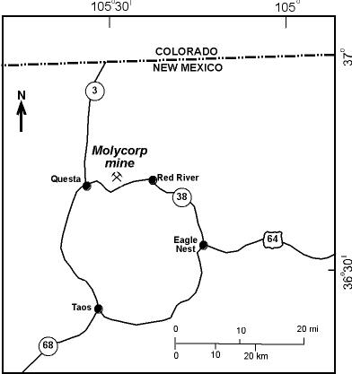
Figure 1. Location of Molycorp Questa mine, northern Taos County, New Mexico.

The mine began production in 1919 from underground workings. Open-pit removal of overburden began in 1964; ore production from the open pit began in 1965 and ended in 1982, at which time approximately 73.5 million metric tons of ore with an average grade of 0.185% MoS₂ had been processed (Schilling, 1960, 1990; Ross et al., 2002; McLemore and Mullen, 2004). Underground mining resumed in 1982 and used block caving mining methods to extract the deeper molybdenum ore. During the open-pit period of mining, approximately 317.5 million metric tons of overburden rock were stripped and deposited onto mountain slopes and into tributary valleys, thereby forming the rock piles examined in this study (URS Corporation, 2000). The elevation of these rock piles ranges from 2301 to 3020 m.
The GHN rock pile is one of nine rock piles created during open-pit mining and contained approximately 10.6 million metric tons of overburden material with slopes similar to the original topography. GHN was divided into two areas: a stable area and an unstable area (Fig. 2). The unstable area had slid downslope since its construction. Molycorp stabilized this rock pile by removing material off the top portion of both areas to the bottom of the pile (Norwest Corporation, 2003). This regrading has decreased the slope, reduced the load, and created a buttress to prevent movement of the rock pile. During the progressive down-cutting of the top of the stable portion of GHN (regrading), trenches were constructed to examine, map, and sample the internal geology of the rock pile.
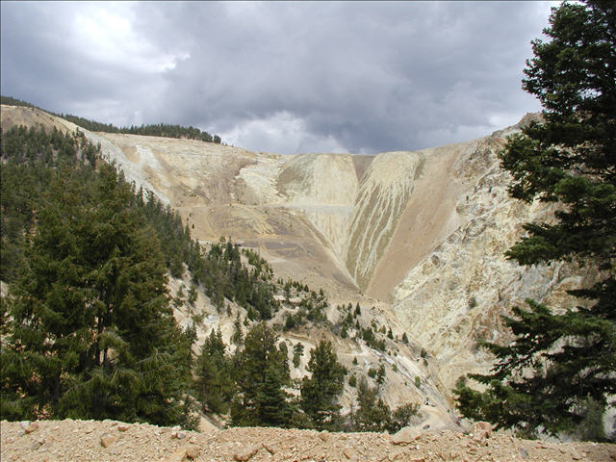
unstable
stable
Figure 2. GHN before regrading, looking east. Solid line indicates approximate location of trenches in summer-fall 2004; dashed line indicates the boundary between the stable and unstable portions of the rock pile.

The Questa rock piles were constructed primarily by haul truck end-dumping in high, single lifts, which involved the dumping of rock over the edge of the hill slopes (URS Corporation, 2000; McLemore et al, 2005, 2006). End-dumping generally results in the segregation of materials with the finer-grained material at the top and coarser-grained material at the base (Fig. 3). The resulting layers locally are at, or near, the angle of repose and subparallel to the original slope angle. End dumping results in these five zones of segregation (Fig. 3; Nichols, 1987; McLemore et al., 2005, 2006):
- Upper traffic surface (compacted by heavy equipment and trucks)
- Top of the rock pile where fines were more abundant than coarser material
- Intermediate zone where material is well graded and evenly distributed
- Toe of the rock pile where mostly coarse material is concentrated
- Basal rubble zone of cobbles and boulders along the contact between the rock pile and the original bedrock or colluvium.

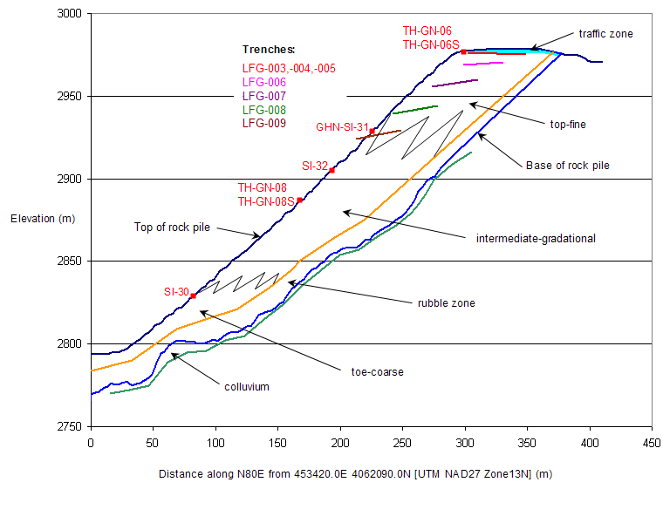
East
West
Figure 3. Conceptual model (cross section) of the Questa GHN rock pile (from field studies at GHN). See text below and McLemore et al. (2005) for explanation of zones. Red dots are drill hole locations. Colored straight lines are trench profiles (names color coded as well).

Procedures

Mapping procedures
Standard geologic mapping techniques were used in this study (Lahee, 1961; McLemore et al., 2005). Each unit on the surface and in the subsurface was examined and described, including the dip, strike, and true thickness. The units were differentiated mostly on the basis of color, grain size, composition, texture, stratigraphic position, dip, thickness, and other soil properties (Fig. 4). Longitudinal sections were made of each bench in the GHN rock pile and geologic maps were made for each trench (Fig. 5). The project geologic mapping, work plans, and procedures describe the mapping, field and laboratory analysis procedures that were used in this study (available upon request). Specific location and construction data for each trench is in the project database (McLemore et al., 2004a).
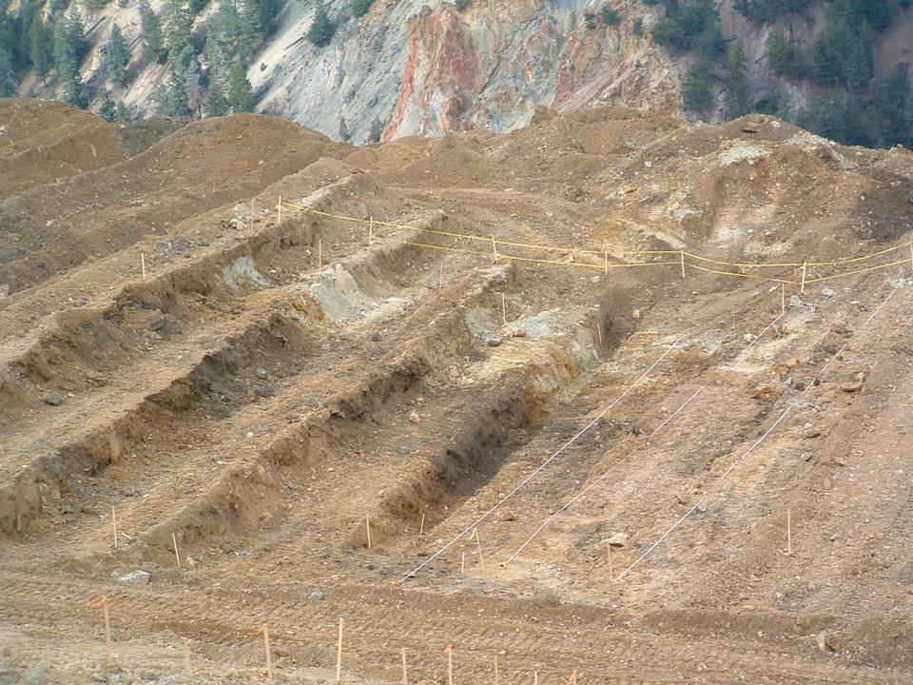

pushed
OUTSIDE
INSIDE
Figure 4. Southwestward view of zonation exposed within a typical trench at outer margin of the GHN rock pile. Note that a trench contains four benches. White zone inside the yellow tape represents outer margin of original dumped pile (pushed material beyond the white zone). Color zones from outer zone to interior pile: Oxidized, leach zone–white to gray to yellow (Unit C, I); oxidized, sulfate accumulation–orange (Unit J); intermediate zone–dark brown (Unit N), internal zones–brown (Units K-W, excluding N). See conceptual model and cross-section given in Figure 3. Geologic units are described below in Table 2.

Sampling procedures
We employed sampling procedures, descriptions, and analytical analyses typically used for soil profiles because the material in the rock piles is similar to mine soils (URS Corporation, 2000; Haering et al., 2004; Stormont and Farfan, 2005). Mine soils are soils that form from organic matter, mineral soil materials, sediments, and rocks redistributed by humans during or after mining (Galbraith, 2004).

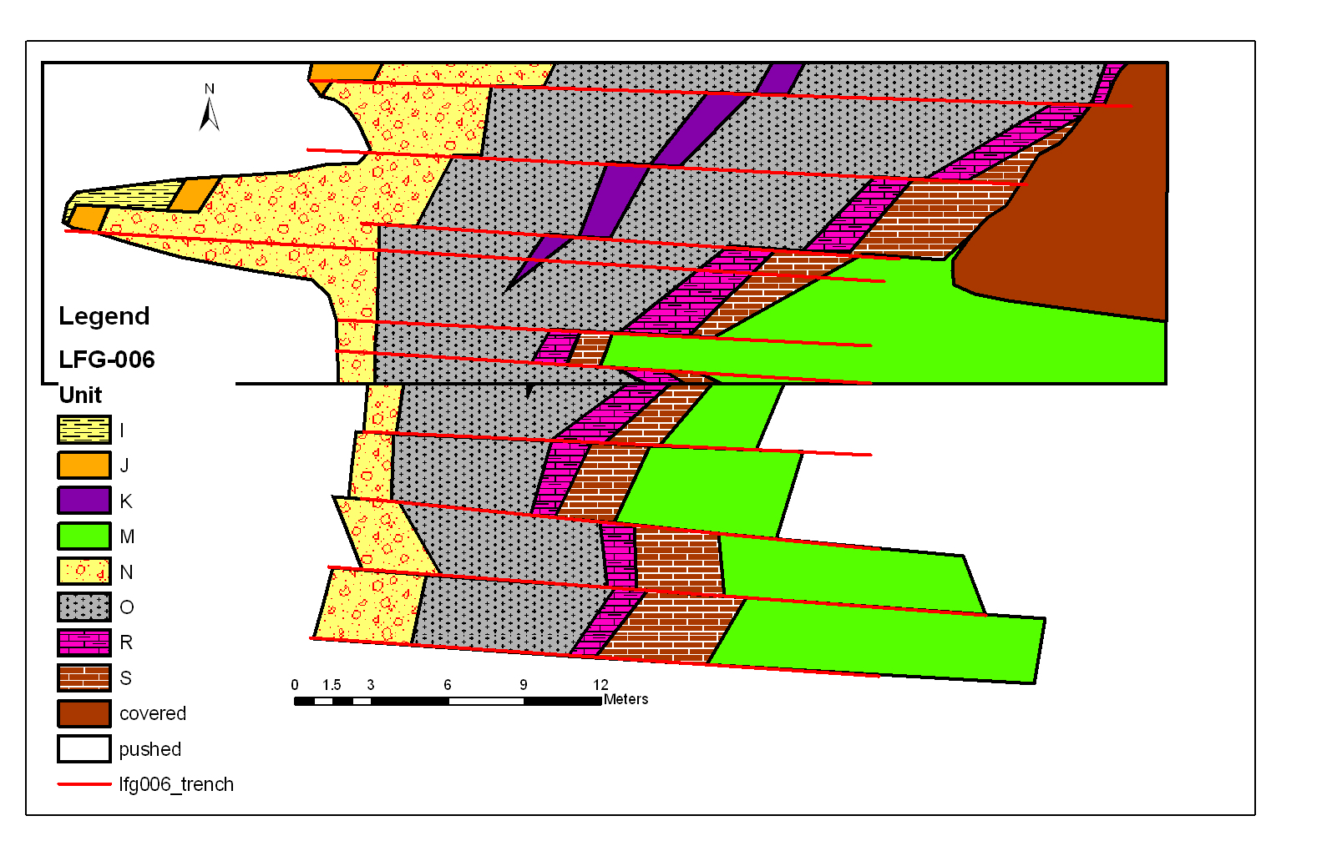
Figure 5. Geologic map of trench LFG-006, stable portion of GHN. Units are described below in Table 2. Offsets show bench wall locations and are not faults. Red lines indicate the edge of each bench. The units closest to the base of the rock pile (east) were emplaced in the pile first before the overlying units towards the outer edge of the rock pile (west). Similar geologic maps were constructed for each trench in the stable portion of GHN.

During GHN regrading, samples of each of the subsurface units were collected after the unit boundaries were identified for geochemical, geotechnical (including shear box tests), biological, isotopic, and electron microprobe analyses. Most samples were channel composites collected along approximate 1.5-m-long horizontal slots using a rock hammer to chip material from bench walls and the material was placed into a sample bag. Some samples were composites collected along specific layers that were less than 1.5 m thick. The entire sample was then analyzed.

Laboratory Procedures
The laboratory paste tests (using a pH meter) and gravimetric moisture contents (by oven drying techniques) were performed at the Mineral Engineering Soils Laboratory and the Bureau of Geology Clay Laboratory at New Mexico Institute of Mining and Technology (NMIMT) using laboratory procedures established as part of the overall project procedures documentation. Petrographic analyses (mineralogy, lithology, hydrothermal and weathering alteration) were performed using a binocular microscope. These analyses were supplemented by microprobe, X-ray diffraction analyses, and whole-rock chemical analyses for confirmation. Clay mineralogy, in terms of the major clay mineral groups was determined using standard clay separation techniques and X-ray diffraction analyses of the clay mineral separates on oriented glass slides (Hall, 2004; Moore and Reynolds, 1989). The concentrations of major and trace elements, except for S, LOI (loss on ignition), and F, were determined by X-ray fluorescence spectrospcopy at the New Mexico State University and at Washington State University laboratories. S and F concentrations were determined by ion probe and LOI concentrations were determined by gravimetric methods at NMIMT.

Description of Goathill North Units

Composition of rock piles based on the material removed from the open pit
The lithologies mined from the open-pit deposit are grouped into five major rock types: rhyolite (Amalia Tuff), andesite breccia, andesite (including latite and quartz latite), granitic porphyry, and aplite. The proportions of various lithologies that were mined from the open-pit deposit were estimated from geologic cross sections through the open pit (Table 1). Other lithologies present in the open-pit deposit included volcaniclastic sandstone, shale, rhyolite and granitic dikes, which were typically included with the andesite breccia or andesite in the cross sections and in Table 1. Field and laboratory analyses revealed that the GHN rock pile consisted primarily of hydrothermally altered andesite and rhyolite (Amalia Tuff) rock fragments.

Description of geologic units in Goathill North
The eighteen lithologic units that were mapped and described for each trench are summarized in Table 2 (McLemore et al., 2005, 2006).
Table 1. Estimates of the volume of each lithology mined from the open-pit deposit determined in this study using Molycorp cross sections. These are rough estimates of the volume of each lithology in the rock piles. Explanation of the lithologies and procedures are in McLemore (2005). QSP—quartz-sericite-pyrite hydrothermal alteration, prop—prophylitic hydrothermal alteration.
Symbol | Lithology | Volume percent | Relative estimate of strength (1 strong, 3 weak) | Comments
Tdqpt-Trt | Rhyolite (Amalia Tuff) | 10 | 1 | Mostly QSP altered, no ore
Tanbx | Andesite breccia | 14 | 3  2 | 50% QSP, 50% prop, no ore
Tanfp | Andesite (including latite and quartz latite) | 46 | 3  2 | 50% QSP, 50% prop, some ore
Thfp | Granite/rhyolite porphyry (Christmas Tree porphyry) | 8 | 2 | QSP altered, no ore, pyrite rich
Tpap | Aplite | 22 | 1 | Most of ore from this unit
TOTAL |  | 100

Table 2. Descriptions of geologic units at GHN. No relative age relationships could be determined between surface units A-H. GHN rock pile material consisted primarily of hydrothermally altered andesite and rhyolite (Amalia Tuff) rock fragments.
Geologic Unit in this report | Description | Structure | Lithology | Location
Surface units
A | Light brown unit with approximately 60% covered by cobbles or larger sized rocks with vegetation growing upon the surface. | Layered in some of the rills near the base. | mixed volcanic rocks | Southern-most surface unit of the stable part
B | Massive, light brown to gray to yellow-brown unit containing crusts of soluble acid salts. Approximately 65% is covered by cobbles or larger sized rocks. Consists of clayey sand with gravel and cobbles and is locally cohesive. | Shallow rills (0.2-1 m deep) of finer grained material are cut into the surface. | quartz-sericite-pyrite (QSP) altered Rhyolite (Amalia Tuff) (70%) and andesite (30%) | Surface unit of stable portion of the GHN rock pile
C | Grayish-brown to yellowish-gray unit consisting of fine-grained materials (sand with cobbles and gravel) and approximately 15% boulders. Locally is cohesive and well cemented by clays and soluble minerals. | Massive alternating zones, up to 10 ft thick. | rhyolite (Amalia Tuff) (70%) and andesite (30%) | Surface unit of stable portion of the GHN rock pile
D | Yellow-brown gravely sand unit that differs from Unit C by a marked increase in cobbles and boulders (approximately 30-40%). | Massive | rhyolite (Amalia Tuff) (80%) and andesite (20%) | Surface unit of unstable portion of the GHN rock pile
E | Orange-brown unit with patches of gray sandy clay containing approximately 15% cobbles and boulders. | Massive | 70 % moderate to strong QSP altered rhyolite (Amalia Tuff) and 30% weakly altered Rhyolite (Amalia Tuff) | Surface unit of unstable portion of the GHN rock pile

Table 2
Geologic Unit in this report | Description | Structure | Lithology | Location
F | Similar to Unit A, consists of dark brown, silty sand with some gravel. | Massive | andesite | Surface unit of unstable portion of the GHN rock pile
G | Orange-brown to yellow-brown sandy gravel with some cobbles, includes colluvium material. | Massive | andesite | Surface unit of unstable portion of the GHN rock pile
H | Dark gray to red-brown V-shaped unit with oxidized orange zones and consists of poorly sorted, well graded, weakly cemented, gravel sand with some fine sand to fine sand with clay and contains approximately 80% cobbles or boulders. | Massive | andesite | Surface unit at the top of stable portion of the GHN rock pile
Outer, oxidized zone
I | Light-gray, poorly sorted, well graded clayey to sandy gravel, medium hard with weak cementation, and no plasticity. The matrix is locally sandy clay with medium to high plasticity. The unit is less cemented and finer grained than the overlying unit C. | Overlain by Unit C, up to 10 ft thick | andesite and rhyolite (Amalia Tuff) | Subsurface oxidized unit of stable portion of the GHN rock pile
J | Dark orange-brown, poorly sorted, well graded, coarse gravel with clay matrix and weak cementation. The top of the unit locally is a bright orange oxidized layer, 2-4 inches thick. | Overlain by unit I, 3-12 ft thick | primarily andesite | Subsurface oxidized unit of stable portion of the GHN rock pile
Interior zones
N | Light to dark brown moderately sorted, uniformly graded, moderately hard sandy clay with cobbles, with moderate to high plasticity and well cemented by clay; contains zones of bright orange to punky yellow oxidized sandy clay. | Heterogeneous with numerous coarse and fine layers, 5-10 ft thick | andesite and rhyolite (Amalia Tuff) | Subsurface unit of stable portion of the GHN rock pile
K | Distinctive purplish-brown gravelly sand with cobbles and is weakly cemented and very coarse containing almost no clay. Cobble layer is locally overlain and underlain by finer gravelly sand layers; contacts are gradational. | grades into Unit O, 0-4 ft thick | primarily andesite | Subsurface unit of stable portion of the GHN rock pile
L | Brown-gray, poorly sorted, well graded gravelly sand with cobbles. | Grades into Unit O | andesite | Subsurface unit of stable portion of the GHN rock pile
O | Brown, poorly sorted, sandy gravel matrix in coarse gravel and cobbles. Numerous coarse and fine layers at varying dips and thicknesses appear in the mass of the unit. The unit has cobbles and clay layers. Heterogeneous, deformed layer with numerous S-shaped clay lenses and coarse layers. | Variable dip of individual beds | primarily andesite | Subsurface unit of stable portion of the GHN rock pile

Table 2
Geologic Unit in this report | Description | Structure | Lithology | Location
M | Orange-brown to brown, poorly sorted, well graded sandy gravel with boulders (up to 1 m diameter). Sandy gravel forms a matrix between boulders and cobbles. The fines are generally gritty. | Unit locally flattens with 20 degree dip | andesite and rhyolite (Amalia Tuff) | Subsurface unit of stable portion of the GHN rock pile
P | Dark brown, poorly sorted, well graded, sandy gravel with medium hardness and no to weak cementation | Pinches out, 0-3 ft thick | andesite | Subsurface unit of stable portion of the GHN rock pile
Q | Dark brown, poorly sorted, well graded, sandy gravel with cobbles with medium hardness and no to minor cementation. | Steeply dipping | andesite | Subsurface unit of stable portion of the GHN rock pile
R | Orange-gray, poorly sorted, well graded sandy gravel to gravel with cobbles with moderate to weak cementation by clay. | Pinches out, 0-3 ft thick | primarily andesite | Subsurface unit of stable portion of the GHN rock pile
S | Dark gray, poorly sorted, well graded sandy silt with no cementation or plasticity. | Pinches out, 0-4 ft thick | primarily andesite | Subsurface unit of stable portion of the GHN rock pile
T | Dark gray, poorly sorted, well graded sandy gravel. |  | andesite | Subsurface unit of stable portion of the GHN rock pile
U | Brown, poorly sorted well graded, sandy gravel with cobbles. | Pinches out, 0-2 ft thick | andesite | Subsurface unit of stable portion of the GHN rock pile
V | Gray to brown-gray, poorly sorted, sandy gravel. | Pinches out, 0-10 ft thick | andesite | Subsurface unit of stable portion of the GHN rock pile
W | Olive gray clay zone, similar and possibly correlated to Unit S. |  | andesite | Subsurface unit of stable portion of the GHN rock pile
rubble zone | Orange-brown, angular cobbles and large boulders (15 cm in diameter) with little sand or clay, cobble-supported rubble zone. Unconformably on top of either soil developed on weathered andesite or colluvium that is similar to the alteration scars. | Unconformable, up to 7 ft thick | andesite, rhyolite (Amalia Tuff) | Basal subsurface unit of stable portion of the GHN rock pile
Shear zone, alluvium, colluvium | Dark gray to brown clayey soil developed on weathered andesite or a yellow to orange brown clay to sandy clay colluvium that is similar to the alteration scars. | 1-3 ft thick | andesite | Original surface, material beneath the rubble zone
bedrock | Gray to dark gray to greenish gray, porphyritic to fine-grained andesite. | Locally fractured | andesite | Original andesite bedrock beneath the soil, alluvium, colluvium

The contact between the GHN rock pile and bedrock/colluvium was exposed and examined in the trenches in several places: (1) at the top of the stable portion of GHN, (2) trenches throughout the unstable portion of GHN, and (3) at the toe of GHN. Observations in the trenches that cut into the base of the rock pile and the bedrock indicated that the basal portion of the GHN rock pile consisted of a cobble-supported rubble zone of gravel through boulder-sized material lying unconformably on top of either (1) a dark gray to brown clayey soil developed on weathered andesite, or (2) a yellow to orange-brown clay to sandy clay colluvium that is associated with the natural alteration scars found along the Red River valley (Meyer and Leonardson, 1990). The rock pile material observed in trenches in the stable portion of GHN overlaid yellow to orange-brown acid-weathered or oxidized soil or colluvium. The rubble zone at the base of the rock pile contained mostly andesite cobbles, jarosite, and gypsum with moderate sorting, and minor clay- to pebble-sized matrix that was developed on top of bedrock.
The results of moisture contents, paste pH, paste conductivity, and paste TDS (total dissolved solids) are presented in McLemore et al. (2006) and are summarized here. Gravimetric moisture contents ranged from 2 to 24% near the surface of the rock piles, but values measured in trenches within the GHN rock pile were typically between 7 and 15% (Fig. 6). Moisture contents as high as 25.5% are reported in previous studies (URS Corporation, 2000). The average paste pH from the GHN pile was 4.39. In previous studies, paste pH varied from 2.1 to 10, paste conductivity varied from 0.19 to 23,000 ms/cm, and paste TDS varied from 1.9 to 1700 ppm (URS Corporation, 2000). Typically, paste pH increased with distance from the outer, oxidized zone (west) towards the interior zone (east) of the GHN rock pile (Fig. 6). The low pH and yellow to orange color, along with the presence of jarosite, gypsum, and a lack of calcite is consistent with oxidized conditions.
Grain-size analyses, including hydrometer analyses, were performed on trench samples from GHN. These results showed gravel, sand, and fines varied from 19 to 76.8%, 22.4 to 63.6%, and 0.36 to 17.4%, respectively (Fig. 7). Most of the samples were classified as poorly-graded or well-graded sandy gravel with a small percentage of fines.

I J N O K M, S R RRRR, R
Figure 6. Paste pH and gravimetric moisture content in percent across bench 9, trench LFG-009. Symbols refer to geologic units described in Table 2. Hfrom is the horizontal distance in feet from the northwest edge of the trench.

Grain shape and texture were assessed by petrographic methods and electron microprobe, and involved examination of the grain shape and texture of the finer-grained soil component of the samples, as well as of the rock fragments within the rock pile material. For rock pile samples, the classification of the shapes of clasts was based on the AGI data sheet 18.1 comparison chart for estimating roundness and sphericity. Based on this classification, sphericity ranged from subprismoidal to subdiscoidal and roundness ranged from very angular to subrounded. Backscattered electron images allow detailed examination of grain shape and texture at small scales. In general, these images revealed a predominance of angular to subangular clasts compared to rounded clasts. The majority of rock pile samples exhibited a clast-supported framework with a clay-sized matrix. However, some samples contained abundant clay-size material and are matrix supported. Pyrite grains, where present, ranged from cubic to rounded, but usually had somewhat rounded edges.

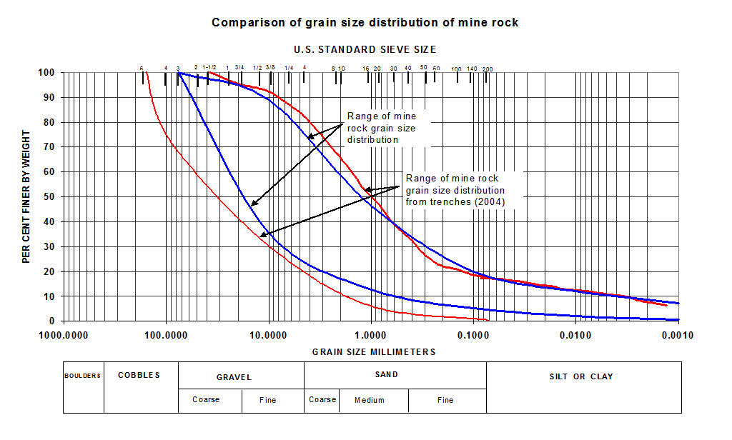
Figure 7. Grain-size analyses of selected samples from GHN compared to legacy data from Molycorp reports. The blue lines are from data in URS Corporation (2000) and the red lines are from data obtained in this study from GHN.

Petrography, Mineralogy, and Chemistry

Petrographic analyses
Petrographic analyses of rock pile material characterized the rock fragment lithology, texture, and mineralogy, especially those minerals that are pertinent to the study of weathering. Soil petrography, aided by electron microprobe, X-ray diffraction, and chemical analyses, provided both a better understanding of variations in the original rock pile and a means to identify the potential mineralogical and chemical effects of weathering. Three sources for mineral phases and chemical elements found in the Questa samples include:
- Primary minerals crystallized in the magma chamber and preserved in the rock (feldspar, quartz, pyroxene, amphibole, magnetite, apatite, etc.)
- Minerals produced before mining by hydrothermal alteration of volcanic rocks (feldspar, pyrite, clay minerals including sericite or illite, quartz, epidote, calcite, apatite, rutile, Fe- and Mn- oxides, etc.)
  - Addition of new elements by the hydrothermal fluids at different times
  - Redistribution of elements dissolved from primary minerals
- Minerals that formed in the rock piles by weathering after mining (gypsum, Fe and Mn oxides, clay minerals, jarosite, etc.)
  - Addition of new elements by meteoric fluids during weathering
  - Redistribution of elements dissolved from primary or hydrothermal phases
A series of samples were examined from a traverse along a single bench (bench 9) within a rock pile trench on GHN that were considered representative of the rock pile (Fig. 8). Mineralogy, lithology, chemical and other analyses of these samples are in Appendix 1. This suite of samples is useful because it provides a profile from the outer margin of the rock pile inward, which allows the comparison of rock fragment lithology and mineral abundance. Eight mappable units were identified along this bench. The geologic map of trench LFG-006 is shown in Figure 5 and the profile of bench 9 is shown in Figure 8.

20 ft
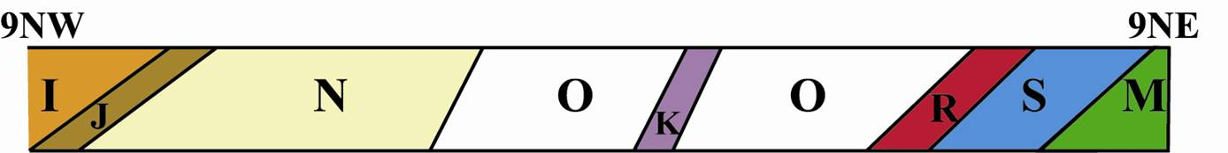
Outer Margin of Rock Pile Inner Portion of Rock Pile
Figure 8. Geologic cross section of bench 9, trench LFG-006. Samples used for petrographic and chemical analysis were obtained at approximately 1.5 m intervals. Refer to this figure for subsequent plots. Description of geologic units is in Table 2. Location of trench LFG-006 is shown in Figure 3.

Two main rock types are found within the population of rock fragments in the GHN samples, andesite and rhyolite (Amalia Tuff). Both exhibited original igneous textures, although the andesite fragments typically have undergone significant hydrothermal alteration, whereas the rhyolite (Amalia Tuff) fragments were relatively pristine. The rhyolite (Amalia Tuff) fragments consisted of large (~mm size) quartz and feldspar phenocrysts surrounded by a devitrified glass matrix. The andesite rock fragments exhibited hydrothermal alteration textures, consisting of fine-grained intergrowths of quartz and potassic feldspar. These rocks also contained dispersed blocky epidote and pyrite crystals. Many of the andesite rock fragments contained considerable concentrations of clay minerals, mainly replacing original igneous phenocrysts, but also as small pockets within the matrix of the samples. Feldspars in both lithologies typically were partially to completely replaced by clay minerals.
The composition of rock fragments and the intensity of hydrothermal alteration are characteristics inherent to rock pile material. These features were present in the rocks before they were emplaced in the rock pile. Understanding these characteristics is important in order to obtain baseline conditions from which weathering can be determined. It is possible to recognize some mapped units based on the relative proportions of the two lithologies that are found within GHN (Fig. 9, Table 2). For example, all samples from unit O contained ≥ 80% andesite rock fragments. Propylitic (chlorite + epidote ± calcite) and QSP (quartz + sericite ± pyrite) were the most common types of hydrothermal alteration found in these samples. The intensities of both types of hydrothermal alteration of rock fragments varied considerably across this bench. QSP hydrothermal alteration intensity appeared to be relatively consistent within mapped units (Fig. 10). QSP alteration is related to the amount of illite (sericite) and quartz found in the samples (Fig. 11). In addition, QSP and propylitic hydrothermal alteration intensities were inversely related and samples with the most QSP hydrothermal alteration usually contained a greater proportion of rhyolite (Amalia Tuff) (Fig. 12).

I J N O K M, S R RRRR, R
Figure 9. Scatter plot of rock fragments lithology (normalized to andesite + rhyolite (Amalia Tuff)) across bench 9, trench LFG-006. Outer oxidized margin of rock pile is on the left (refer to Figure 8 for geologic section and Table 2 for description of geologic units). Hfrom is the horizontal distance in feet from the northwest edge of the trench.
I J N O K M, S R RRRR, R
Figure 10. Scatter plot of QSP hydrothermal alteration intensity in weight percent (defined by the percentage of hydrothermal alteration minerals that have replaced primary minerals in rock fragments) and SiO₂ in weight percent across bench 9, trench LFG-006. Refer to Figure 8 for geologic section and Table 2 for description of geologic units. Hfrom is the horizontal distance in feet from the northwest edge of the trench.

The minerals gypsum, pyrite, and carbonate provided insight into the process of post-mining weathering that has occurred since the material from the open pit was deposited in the rock pile. In the GHN rock pile, gypsum occurred with distinctly different crystal habits, that have different stable isotopes (δ¹⁸O, δ³⁴S). Clear, prismatic crystals are authigenic, formed after the material was emplaced in the rock pile (Fig. 13; Campbell et al., 2005). Authigenic gypsum is quite distinct isotropically and texturally from gypsum formed in the hydrothermal system that occurred before mining. This material was likely a product of weathering. The abundance of authigenic gypsum decreased from the outer, oxidized margin to the interior portion of the rock pile (Fig. 14). Conversely, the abundance of carbonate generally increased from the outside to the inside of the rock pile (Fig. 15). Additionally, carbonate abundance was correlated to paste pH. Samples with abundant carbonate (n=4) have paste pH values between 8.4 and 9.6, whereas those with no detectable carbonate (n=7) have paste pH values between 2.2 and 3.7 (McLemore et al., 2006). This finding implies carbonate was at least partially controlling pH by neutralizing acid produced by the oxidation of pyrite. Pyrite was not common in rock pile samples from bench 9, trench LFG-006. Pyrite comprised up to 2% of unit I, the outermost unit, but otherwise occurred only in trace amounts.
I J N O K M, S R RRRR, R
Figure 11. Scatter plots of QSP hydrothermal alteration of rock fragments and quartz (Q) and illite (illite is a form of sericite) in weight percent in the same rock fragments. Hfrom is the horizontal distance in feet from the northwest edge of the trench. R² of regression line for QSP vs. Q is 0.88 and for QSP vs. illite is 0.92. Refer to Figure 8 for geologic section and Table 2 for description of geologic units.

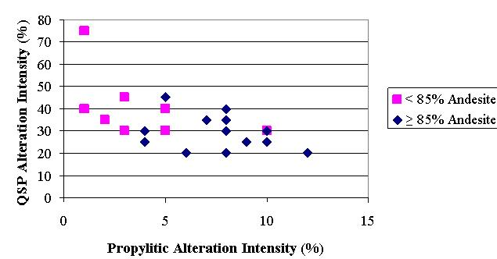

Figure 12. Intensity of propylitic hydrothermal alteration versus intensity of QSP hydrothermal alteration for rock pile samples from bench 9, trench LFG-006.

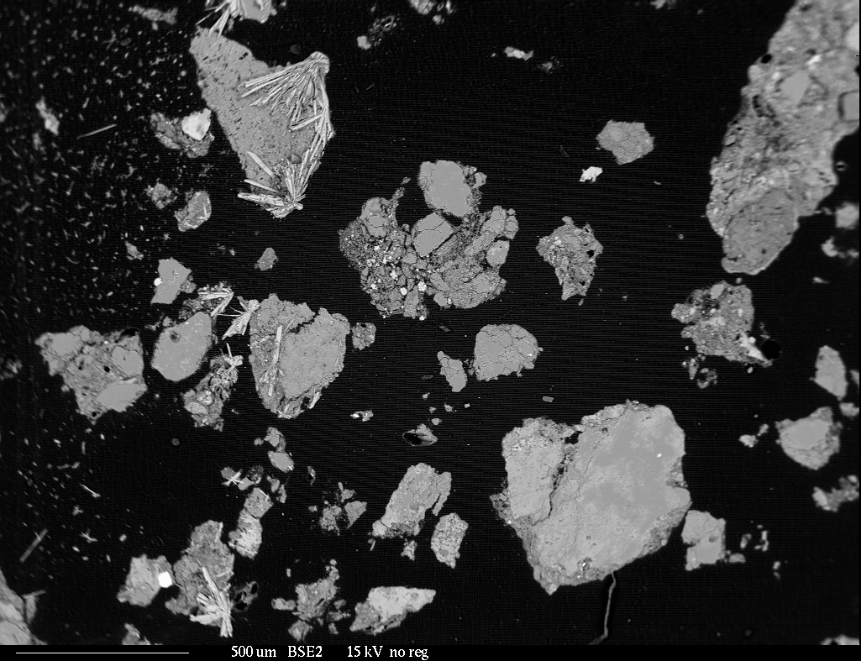
Authigenic
Gypsum
Figure 13. Backscattered electron image of rock pile sample from unit I. Bladed, prismatic crystals are authigenic gypsum.

I J N O K M, S R RRRR, R
Figure 14. Abundance of authigenic (AuthGyp) and detrital (DetritGyp) gypsum in weight percent across bench 9, trench LFG-006. Outside of rock pile is on the left (refer to Figure 8 for geologic section and Table 2 for description of geologic units). Hfrom is the horizontal distance in feet from the northwest edge of the trench.

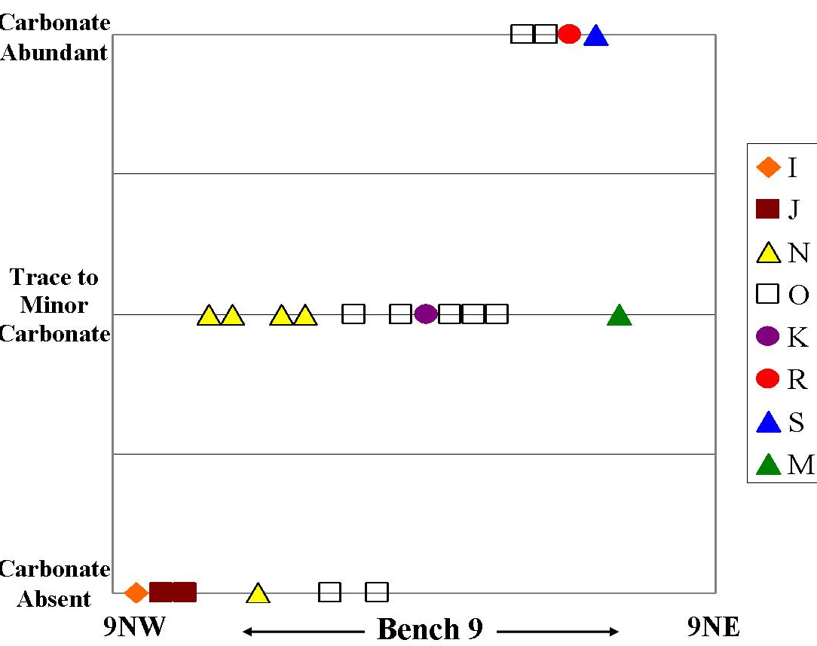
Figure 15. Scatter plot of carbonate (predominantly calcite) abundance across bench 9, trench LFG-006. Refer to Figure 8 for geologic section and Table 2 for description of geologic units.

Chemical analyses
The whole-rock chemical composition reflects the mineralogy of the sample (Table 3), which is controlled by the lithology and hydrothermal alteration history.
Low paste pH samples have low MnO, CaO, and Sr, and higher S, F and LOI (loss on ignition, related in part to clay minerals) and with increase in pH, generally MnO, CaO, and Sr increased and S, F and LOI decreased (Fig. 15). Linear trends in the scatter plots are not observed because the samples are a mixture of andesite and rhyolite with different degrees of hydrothermal alteration. This suggests that paste pH is controlled not only by carbonate and sulfate minerals (as discussed above), but also by hydrothermal clay minerals and minerals containing F (fluorite, apatite, clay minerals, beryl, muscovite, Table 3). A high LOI corresponds to a higher concentration of clay minerals and gypsum.
Various chemical elements show similar trends and correlations with mineralogy across bench 9, trench LFG-009 on GHN. CaO and Sr increase in concentration across bench 9 (Fig. 16), similar to the increasing trend in calcite (Fig. 15). Plagioclase and K-feldspar show little change across bench 9, whereas Al₂O₃ shows a minor increase in concentration across bench 9 (Fig. 17). Many of the major minerals in GHN also contain Al₂O₃ (Table 3). Epidote and chlorite, along with MgO and MnO, show an increase across bench 9 and indicate the control of MgO and MnO concentrations on concentrations of epidote and chlorite (Fig. 18).

Table 3. Relative stabilities, approximate concentrations (subject to change with additional petrographic studies), and compositions of minerals found in Questa rock pile deposits that were obtained from NMIMT electron microprobe analyses (in bold) and from Molling (1989), Shum (1999), Piche and Jebrak (2004). Tr=trace
Relative stability | Mineral | Approx % | Primary elements | Trace elements | Chemical Formula
Easily weathered | pyrite | 0-8 | Fe, S | Cu, Te, Co, Pb | FeS2
 | calcite | 0-5 | Ca, CO | Sr, Al, Mg, Mn, Fe, Si, Ba, P | CaCO3
 | anhydrite | tr | Ca, S |  | CaSO4
 | hornblende | 0-tr | Mg, Fe, Ca, Al, Si | Ni, Co, Mn, Sc, Si, V, Zn, Cu, Ga | Ca₂(Mg,Fe,Al)₅(OH)₂[(Si,Al)₄O₁₁]₂
 | Biotite/ phlogopite | 0-13 | K, Mg, Fe, Al, Si | F, Rb, Ba, Ni, Co, Li, Mn, V, Zn, Cu, Ga | KFe3AlSi3O10(OH, F, Cl)2
 | apatite | 0-1 | Ca, P, F | Si, S, Mn, Fe, Sr, Cl, REE, Pb, Y | Ca5P3O12·(OH, F, Cl)
 | jarosite | 0-0.5 | Fe, S, H, K |  | KFe3(SO4)2(OH)6
 | alunite | 0-0.5 | S, K |  | K₂Al₆(OH)₁₂(SO₄)₄
Table 3
 | copiapite | 0-0.5 | Fe, S |  | Fe+2(Fe+3)4(SO4)6(OH)2·20H2O
 | sphalerite | 0-0.1 | Zn, S | Cd | ZnS
Relative stability | Mineral | Approx % | Primary elements | Trace elements | Chemical Formula
 | chalcopyrite | 0-0.1 | Cu, Fe, S |  | CuFeS₂
 | galena | 0-0.1 | Pb, S | Ag | PbS
Moderateweathered | fluorite | 0-0.1 | Ca, F | Y | CaF₂
 | dolomite | 0-0.1 | Mg, Ca, CO | Sr, Al, Mg, Mn, Fe, Si, Ba | MgCa(CO₃) ₂
 | rhodo-chrosite | 0-0.1 | Mn, Ca, CO |  | MnCO₃
 | albite |  | N, Al, Si | Cu, Ga, Ba, Sr, | NaAlSi₃O₈
 | orthoclase | 0-24 | K, Al, Si | Rb, Ba, Sr, Cu, Ga | KAlSi₃O₈
 | anorthite | 0-20 | Ca, Al, Si | Ba, Sr, | CaAl2Si₂O₈
 | Muscovite (sericite, illite) | 0-30 | K, Al, Si | F, Cl, Ti, Cr, Mg, Na, Ca, Mn, Fe, Rb, Ba, Sr, Ga, V, Be?, Li? | KAl₂ (Si₃AL)O₁₀(OH) ₂
 | magnetite | 0-1 | Fe, Ti | Al, Mg, Ca, Mn, Zn, Co, Ni, Cr, V | Fe₃O₄
 | Epidote | 0-16 | Ca, Al, Si | Cr, Mg, Mn, Fe, Na, Ti | CaFeAl₂3(SiO₄) ₃(OH)
 | chlorite | 0-12 | Fe, Al, Mg, Si, Be? | F, Be?, Li?, various | Mg₃Fe₂Al₂Si₃O₁₀(OH) ₈
 | smectite | 0-24 | Si, Al, Mg, Ca, Na, K, Be? | P, S, Ti, Mn, Fe, F, Cl, Be?, Li? | Ca0_{0.33}(Mg_{0.66}Al_{3.34})(Si₈)(OH) ₈
 | chromite | 0-0.1 | Fe, Cr |  | FeCrO₄
 | titanite | 0-0.1 | Ca, Ti, Si |  | CaTiSiO₄·OH
 | rutile | 0-0.1 | Ti |  | TiO₂
 | beryl | 0-0.01 | Be |  | Be₃Al₂(SiO₃)₆
 | barite | 0-0.01 | Ba, S | Sr | BaSO₄
 | actinolite | 0-1 | Ca, Mg, Si, OH |  | Ca₂Mg₅Si₈O₂₂ (OH₂
Very stable | quartz | 0-66 | Si |  | SiO₂
 | kaolinite | 0-7 | Al, H, Si | F, Cl | Al₂Si₂O₅(OH) ₂
 | gypsum | 0-20 | Ca, S | Sr, Ba | CaSO₄·H2O
 | ferrihydrite | 0-0.01 | Fe |  | Fe(OH) ₃
 | hematite | 0-10 | Fe | Various | Fe₂O₃
 | goethite | 0-1 | Fe | Various | FeOOH
 | FeMnTi oxides | 0-10 | Fe, Mn, Ti | various
 | molybdenite | 0-0.1 | Mo, S |  | MoS Fe₂O₃
 | Amorphous Si, Fe, Mn, Al | ? | Si, Fe, Mn, Al | various | various

I J N O K M, S R RRRR, R
Figure 15. Scatter plots showing the correlation of MnO, CaO, S, LOI, Sr, and F in weight percent with paste pH, bench 9, Trench LFG-009. Hfrom is the horizontal distance in feet from the northwest edge of the trench. See Table 2 for description of the geologic units.
I J N O K M, S R RRRR, R
Figure 16. Scatter plots of CaO and Sr and correlation of CaO and Sr in weight percent across bench 9. Hfrom is the horizontal distance in feet from the northwest edge of the trench. See Table 2 for descriptions of the geologic units.
I J N O K M, S R RRRR, R
Figure 17. Plagioclase (P), K-feldspar (A) and Al₂O₃ in weight percent plotted across bench 9, trench LFG-006. Refer to Figure 9 for geologic section. Hfrom is the horizontal distance in feet from the northwest edge of the trench. See Table 2 for descriptions of the geologic units.
I J N O K M, S R RRRR, R
Figure 18. Plots showing the correlation between epidote and chlorite and MgO and MnO in weight percent across bench 9. Hfrom is the horizontal distance in feet from the northwest edge of the trench. See Table 2 for descriptions of the geologic units.

Summary
Nineteen trenches were constructed in the GHN rock pile as it was regraded in 2004-2005. Detailed geologic mapping and sampling revealed mappable geologic units in the rock pile. Units were defined on the basis of grain size, color, texture, stratigraphic position, and other physical properties that could be observed in the field. Units were correlated between benches and to opposite sides of each trench, and several units were correlated downslope through the excavated trenches. Eighteen geologic units were differentiated, described, and sampled.
Typically, paste pH increased with distance from the outer, oxidized zone (west) towards the interior units (east) of the GHN rock pile. The outer zone was oxidized (weathered) based upon the white and yellow coloration, low paste pH, presence of jarosite and authigenic gypsum, and absence of calcite. The base of the rock pile adjacent to the bedrock/colluvium surface represents the oldest part of the rock pile because it was laid down first. Portions of the base appeared to be nearly or as oxidized (weathered) as the outer, oxidized zone of the rock pile, suggesting that air and water flow along the basal interface occurred, implying that it could have been an active weathering zone.
Characterization of original rock pile material was accomplished by petrographic, mineralogical, and chemical analyses and included descriptions of rock fragment lithology and hydrothermal alteration type and intensity in the rock fragments. Little, if any, fresh, unaltered primary igneous material was emplaced in the GHN rock pile. Most of the material was hydrothermally altered prior to mining (i.e. prior to placement in GHN rock pile). The GHN rock pile material was composed of mixtures of two lithologies, andesite and rhyolite (Amalia Tuff). Clay mineral analyses revealed the presence of kaolinite, smectite, illite (sericite, mica), and chlorite, as well as random mixed layer clays within the GHN rock pile material. These clay minerals were derived from the original, pre-mined hydrothermal alteration and not post-mining weathering (McLemore et al., 2006). The physical break-down of the rock during the excavation process and subsequent placement to form the rock piles most likely released clay minerals contained within phenocrysts and groundmass. It is expected that with increased weathering, clay minerals could form in the rock pile in the future.
The samples collected from GHN are heterogeneous as indicated above by being mixtures of two lithologies and three hydrothermal alteration assemblages. This sample heterogeneity is reflected by the lack of clear, well correlated linear mineralogical and chemical correlations on the scatter plots (Fig. 9-12, 14-18). However despite the sample heterogeneity, some trends are clearly indicated by the data. The whole-rock chemistry is directly correlated with the whole-rock mineralogy (Table 3). Chemical trends within the GHN rock pile are related to changes in the lithology, hydrothermal alteration before mining, and weathering where water was present in the rock pile to promote weathering process. However, as a result of (1) the mixture of two lithologies and three distinctly different hydrothermal alteration assemblages and (2) the effects of post-depositional weathering, geochemical trends that might be related to hydrothermal alteration and weathering in these rocks are nonlinear. Another source of the sample heterogeneity could be the different grain size distributions of the GHN material, which can result in different surface areas being exposed to weathering. Different weathering behavior in different parts of the rock pile is a result of differences in:
- original mineralogy and chemical composition of the rock pile material before mining
- heterogeneous water and air flow through the rock pile
- composition of waters flowing through the rock pile (unknown)
- grain size (as a result of abrasion, chemical weathering, sorting, volume change due to conversion of anhydrite to gypsum and freeze-thaw cycling) (smaller grain size results in more surface area, which results in larger capacity for oxidation and weathering)
- presence of microbes.
All of these factors, along with climate, affect weathering and contribute to zones of increased weathering intensity at and near the surface of the GHN rock pile, as well as other areas within the rock pile that have water and water vapor (air) moving through.

Acknowledgements

This project was funded by Molycorp, Inc. and the New Mexico Bureau of Geology and Mineral Resources (NMBGMR), a division of New Mexico Institute of Mining and Technology. We would like to thank the professional staff and students of the large multi-disciplinary field team for their assistance in mapping, sampling, and laboratory analyses. We also would like to thank Jim Vaughn and Mike Ness of Molycorp, Inc. and John Purcell of Golder Associates for their training and assistance in this study. Dave Jacobs and two anonymous reviewers commented on this paper and their comments are appreciated. This paper is part of an on-going study of the environmental effects of the mineral resources of New Mexico at NMBGMR, Peter Scholle, Director and State Geologist. This manuscript was reviewed by three anonymous reviewers and their comments were helpful and appreciated.

Literature Cited

Briggs, P. H., Sutley, S. J., and Livo, K. E. 2003. Questa Baseline and Pre-mining Ground Water Investigation: 11. Geochemistry of composited material from alteration scars and mine-waste piles. U. S. Geological Survey Open-File Report 03-458, 17 p., http://pubs.usgs.gov/of/2003/ofr-03-458/
Campbell, A. R., Lueth, V. W., and Pandey, S. 2005. Stable Isotope Discrimination of Hypogene and Supergene Sulfate Minerals. In: Rock Piles at the Questa Molybdenum Mine, New Mexico (abstr.). Geological Society of America, Abstracts with programs.
Carpenter, R. H. 1968. Geology and ore deposits of the Questa molybdenum mine area, Taos County, New Mexico In: Ore deposits of the United States, 1933-1967, Granton-Sales, J.D., Ridge, ed. AIME, p.1328-1350.
Clark, K. F. 1968. Structural controls in the Red River District, New Mexico. Economic Geology, v. 63, p. 553-566.
Czamanske, G. K., Foland, K. A., Hubacher, F. A. and Allen, J. C. 1990. The ⁴⁰Ar/³⁹Ar chronology of caldera formation, intrusive activity and Mo-ore deposition near Questa, New Mexico. New Mexico Geological Society Guidebook 41, p. 355-358.
Dawson, R. F. 1994. Mine waste geotechnics. University of Alberta, Edmonton, Ph.D. thesis, 262 p.
Fines, P., Wilson, G. W., Williams, D. J., Tran, A. B., and Miller, S. 2003. Field characterization of two full-scale waste rock piles. In: ICARD 2003—Proceedings from the 5th international conference on acid rock drainage. The Australasian Institute of Mining and Metallurgy, Melbourne, p. 903-909.
Galbraith, J. M. 2004. Proposed changes to soil taxonomy that may affect mine soil classification. In: 2004 National Meeting of the American Society of Mining and Reclamation. American Society of Mining and Reclamation, CD-ROM, 14 p.
Haering, K. C., Daniels, W. L., and Galbraith, J. M. 2004. Appalachian Mine Soil Morphology and Properties. Effects of Weathering and Mining Method. Soil Science Society America Journal, v. 68, p.1315–1325.
Hall, J. S. 2004. New Mexico Bureau of Mines and Mineral Resource’s Clay Laboratory Manual. Unpublished New Mexico Bureau of Geology and Mineral Resources report.
Lahee, F. H. 1961. Field geology: McGraw-Hill Book Company, New York, 926 p.
Lipman, P. W. and Reed, J. C., Jr. 1989. Geologic map of the Latir volcanic field and adjacent areas, northern New Mexico. U. S. Geological Survey, Miscellaneous Investigations Map I-1907, scale 1:48,000.
Livo, K. E. and Clark, R. N. 2002. Mapped minerals at Questa, New Mexico, using airborne visible-infrared imaging spectrometer (AVIRIS) data - preliminary report for first quarterly report of the U. S. Geological Survey investigation of baseline and pre-mining ground-water quality in the Red River valley basin, New Mexico, November 13, 2001. U. S. Geological Survey, Open-file Report 02-0026, 13 p., http://pubs.usgs.gov/of/2002/ofr-02-0026/
McLemore, V. T. 2005. Lithologic atlas for the Questa mine. Unpublished report to Molycorp, Inc, Task 1.2.2, 23 p.
McLemore, V.T., Donahue. K. M., Walsh, P., Tachie-Menson, S., Phillips, E.H., Guitierrez, L. A. F., and Shannon, H. R. 2005. Trench Sampling of the Molycorp Goathill North rock piles, Questa Rock Pile Stability Study, New Mexico. National Meeting of the American Society of Mining and Reclamation, Breckenridge, Colo, June, CD-ROM, 26 p. http://geoinfo.nmt.edu/staff/mclemore/Molycorppapers.htm
McLemore, V. T., Donahue. K. M., Phillips, E.H., Dunbar, N., Walsh, P., Guitierrez, L. A. F., Tachie-Menson, S., Shannon, H. R., Lueth, V. W., Campbell, A. R., Wilson, G. W., and Walker, B. M., 2006. Characterization of Goathill North mine rock pile, Questa molybdenum mine, Questa, New Mexico. 7th ICARD, March 26-30, 2006, St. Louis MO. Published by American Society of Mining and Reclamation., Lexington, KY. CD-ROM, p. 1219-1249. http://geoinfo.nmt.edu/staff/mclemore/Molycorppapers.htm
McLemore, V. T., Hoffman, G. K., Wilks, M., Raugust, J. S., and Jones, G. R. 2004a. Use of databases in characterization at mine sites. In: 2004 National Meeting of the American Society of Mining and Reclamation, Morgantown, WV, April 2004, CD-ROM, http://geoinfo.nmt.edu/staff/mclemore/Molycorppapers.htm
McLemore, V. T. and Mullen, K. E. 2004. Mineral resources in Taos County, New Mexico. In: New Mexico Geological Society, Guidebook 55, p. 383-390, http://geoinfo.nmt.edu/staff/mclemore/Molycorppapers.htm
McLemore, V. T., Russell, C. C., Smith, K. S. and the Sampling and Monitoring Committee of the Acid Drainage Technology Initiative—Metals Mining Sector (ADTI—MMS). 2004b. Sampling and Monitoring for Closure. Society of Mining, Exploration, and Metallurgy, SME Preprint No. 04-62, CD-ROM, 10 p.
Meyer, J. W. 1991. Volcanic, plutonic, tectonic and hydrothermal history of the southern Questa Caldera, New Mexico. University Microfilms, Ph.D. dissertation, 348 p.
Meyer, J. and Foland, K. A. 1991. Magmatic-tectonic interaction during early Rio Grande rift extension at Questa, New Mexico. Geological Society of America Bulletin, v. 103, p. 993-1006.
Meyer, J. W., and Leonardson, R. W. 1990. Tectonic, hydrothermal and geomorphic controls on alteration scar formation near Questa, New Mexico. In: New Mexico Geological Society, Guidebook 41, p. 417-422.
Moore, O. M. and Reynolds, R. O., Jr. 1989. X-ray diffraction and the identification and analyses of clay minerals. Oxford University Press, New York.
Munroe, E. A. and McLemore, V. T. 1999. Waste rock pile characterization, heterogeneity and geochemical anomalies in the Hillsboro mining district, Sierra County, New Mexico. Journal of Geochemical Exploration, v. 66, p. 389-405.
Munroe, E. A., McLemore, V. T., and Dunbar, N. W. 2000. Mine waste rock pile geochemistry and mineralogy in southwestern New Mexico, USA. In: ICARD 2000—Proceedings from the 5th international conference on acid rock drainage. Society for Mining, Metallurgy, and Exploration, Inc., Littleton, Colo. p. 1327-1336.
Nichols, R. S. 1987. Rock segregation in waste dumps. In: Flow-through rock drains: Proceedings of the International symposium convened at the Inn of the South, Cranbrook, B.C., September 8-11, 1986.
Norwest Corporation. 2003. Goathill North Slide Investigation, Evaluation and Mitigation Report. Norwest Corporation report, 56 p. http://www.emnrd.state.nm.us/Mining/Moly/final/Final%20Goathill%20North.pdf
Phillips, E. H., Lueth, V., Campbell, A., McLemore, V. T., Walker, B., and Tachie-Menson, S. 2005. Soil petrography of a sample traverse from a portion of the Goathill North Rock Pile, Questa Mine, New Mexico (abstr.). New Mexico Geological Society, Spring Meeting, Abstracts Volume. Also New Mexico Geology, v. 27, p. 47.
Quine, R. L. 1993. Stability and deformation of mine waste dumps in north-central Nevada. M.S. thesis, University of Nevada, Reno, 402 p.
Roberts, T. T., Parkison, G. A., and McLemore, V. T. 1990. Geology of the Red River district, Taos County, New Mexico. In: New Mexico Geological Society, Guidebook 41, p. 375-380.
Robertson GeoConsultants Inc. 2000a. Progress report: Results of phase 1 physical waste rock characterization, Questa, New Mexico. Unpublished report to Molycorp, Inc., 052007/4, June, at www.molycorp.com.
Robertson GeoConsultants, Inc. 2000b. Interim mine site characterization study, Questa Mine, New Mexico. Unpublished report to Molycorp, Inc., 052008/10, November, at www.molycorp.com.
Ross, P. S., Jebrak, M., and Walker, B. M. 2002. Discharge of hydrothermal fluids from a magma chamber and concomitant formation of a stratified breccia zone at the Questa porphyry molybdenum deposit, New Mexico. Economic Geology, v. 97, p. 1679-1699.
Rowe, A. 2005. Fluid evolution of the magmatic hydrothermal breccia of the Goat Hill orebody, Questa Climax-type porphyry molybdenum system, New Mexico—a fluid inclusion study. M.S. thesis, New Mexico Institute of Mining and Technology, Socorro, 134 p.
Schilling, J. H. 1960. Mineral resources of Taos County, New Mexico. New Mexico Bureau of Mines and Mineral Resources, Bulletin 71, 124 p.
Schilling, J. H. 1990. A history of the Questa molybdenum (moly) mines, Taos County, New Mexico. In: New Mexico Geological Society, Guidebook 41, p. 381-386.
Shaw, S., Wels, C., Robertson, A., and Lorinczi, G. 2002. Physical and geochemical characterization of mine rock piles at the Questa mine, New Mexico. In: Tailings and Mine Waste '02, Proceedings of the Ninth International Conference on Tailings and Mine Waste: Fort Collins, Colorado, USA, 27-30 January, p. 447-458. http://www.robertsongeoconsultants.com/papers/shapag.pdf.
Shum, M. G. W. 1999. Characterization and dissolution of secondary weathering products from the Gibraltar mine site. M. S. thesis, University of British Columbia, Vancouver, 310 p.
Smith, K. S., Briggs, P. H., Campbell, D. L., Castle, C. J., Desborough, G. A., Eppinger, R. G., III, Fitterman, D. V., Hageman, P. L., Leinz, R. W., Meeker, G. P., Stanton, M. R., Sutley, S. J., Swayze, G. A., and Yager, D. B. 2000. Tools for the rapid screening and characterization of historical metal-mining waste dumps. In: Proceedings of the 2000 Billings Land Reclamation Symposium, Billings, Montana, March 20-24, 2000: Bozeman, Montana State University, Reclamation Research Unit Publication No. 00-01 (CD-ROM), p. 435-442. http://crustal.usgs.gov/minewaste/pdfs/ksmith_billings.pdf.
Smith, K. S., Ramsey, C. A. and Hageman, P. L. 2000b. Sampling strategy for rapid screening of mine-waste dumps on abandoned mine land. In: proceedings; in ICARD 2000—Proceedings from the 5th International Conference on Acid Rock Drainage. Society for Mining, Metallurgy and Exploration, Inc., v. II, p. 1453-1461.
Stormont, J. C. and Farfan, E. 2005. Stability evaluation of a mine waste pile. Environmental and Engineering Geoscience, Vol. XI, No. 1, February 2005, p. 43–52.
Tran, A. B., Miller, S., Williams, D. J., Fines, P., and Wilson, G. W. 2003. Geochemical and mineralogical characterization of two contrasting waste rock dumps—The INAP waste rock dump characterization project. In: ICARD 2003—Proceedings from the 5th international conference on acid rock drainage: The Australasian Institute of Mining and Metallurgy, Melbourne, p. 939-947.
URS Corporation. 2000. Interim mine rock pile erosion and stability evaluations, Questa Mine, Unpublished report to Molycorp, Inc., 6800044388.00, December 1. www.molycorp.com.
van Dam, R. L., Gutierrez, L. A. , McLemore, V. T., Wilson, G. W., Hendrickx, J. M. H., and Walker, B. M. 2005. Near surface geophysics for the structural analysis of a mine rock pile, northern New Mexico. In: 2005 National Meeting of the American Society of Mining and Reclamation, Breckenridge, Colorado, June, CD-ROM.
Wagner, A. M. and Harrington, J. T. 1995. Revegetation report for Molycorp, Inc. Questa mine site. unpublished report for Vail Engineering, 45 p.
Wels, C., Loudon, S., Fortin, S. 2002. Factors influencing net infiltration into mine rock piles at Questa Mine, New Mexico. In: Tailings and Mine Waste '02: Proceedings of the Ninth International Conference on Tailings and Mine Waste: Fort Collins, Colorado, USA, 27-30 January, p. 469-477. http://www.robertsongeoconsultants.com/papers/welfin.pdf.
Wildeman, T. R., Ranville, J. F., Herron, J., and Robinson, R. H. 2003. Development of a simple scheme to determine the chemical toxicity of mine wastes. In: Proceedings, 2003 National Meeting of the American Society of Mining and Reclamation and 9th Billings Land Reclamation Symposium, Billings, MT, June 3-6, 2003. Lexington, Kentucky, American Society of Mining and Reclamation.

APPENDIX 1. Chemical and other analyses of GHN samples from bench 9, trench LFG-006. Hfrom is the horizontal distance from the NW edge of the trench. Blank space indicates no data. Major and trace elements, except S, LOI (loss on ignition), and F are by X-ray fluorescence. S and F are by ion probe. LOI is by gravimetric methods. Paste tests are by pH meter. Mineralogy, rock fragments, and hydrothermal alteration are by petrographic methods confirmed by x-ray diffraction, whole-rock chemistry, and electron microprobe.
Sample | GHN-KMD-0013 | GHN-KMD-0015 | GHN-KMD-0016 | GHN-KMD-0017 | GHN-KMD-0018 | GHN-KMD-0019 | GHN-KMD-0026 | GHN-KMD-0027 | GHN-VTM-0194
In percent
SiO₂ | 63.68 | 63.83 | 61.88 | 61.34 | 70.45 | 61.78 | 69.83 | 68.03 | 61.99
TiO₂ | 0.6 | 0.7 | 0.79 | 0.61 | 0.36 | 0.81 | 0.32 | 0.43 | 0.55
Al₂O₃ | 14.59 | 14.36 | 14.44 | 14.37 | 12.95 | 14.94 | 12.81 | 12.93 | 13.18
Fe₂O₃T | 6.23 | 5.72 | 5.51 | 6.03 | 3.48 | 5.35 | 3.86 | 4.57 | 5.09
MnO | 0.07 | 0.37 | 0.31 | 0.08 | 0.22 | 0.32 | 0.15 | 0.21 | 0.13
MgO | 1.46 | 2.05 | 2.83 | 1.51 | 1.23 | 3.14 | 0.76 | 1.05 | 1.51
CaO | 1.17 | 1.38 | 2.97 | 1.15 | 0.81 | 3.59 | 0.5 | 0.56 | 1.27
Na₂O | 2.42 | 2.49 | 3.36 | 2.5 | 1.29 | 3.48 | 2.59 | 2.03 | 2.28
K₂O | 3.68 | 4.07 | 3.12 | 3.49 | 4.81 | 2.92 | 4.26 | 4.15 | 3.52
P₂O₅ | 0.23 | 0.25 | 0.29 | 0.23 | 0.08 | 0.26 | 0.13 | 0.19 | 0.27
S | 0.29 | 0.13 | 0.13 | 3.06 | 0.8 | 0.01 | 0.17 | 0.26 | 2.05
LOI | 4.81 | 3.7 | 3.42 | 7.4 | 4.2 | 4.3 | 3.53 | 4.48 | 8.05
In parts per million
F | 1120 | 1376 | 993 | 1507 | 1217 | 1032 | 753 |  | 1511
Ba | 1015 | 1564 | 1174 | 1186 | 712 | 1065 | 609 | 726 | 778
Rb | 99 | 102 | 76 | 118 | 149 | 73 | 127 | 130 | 112
Sr | 367 | 421 | 579 | 183 | 197 | 668 | 191 | 221 | 161
Pb | 158.5 | 117.4 | 186.2 | 125.2 | 154 | 154 | 81 | 103 | 93
Th | 9.82 | 10.34 | 7.82 | 13.39 | 10.45 | 8 | 13 | 13 | 12
U | 3.59 | 1.65 | 2.52 | 3.98 | 4.31 | 3 | 5 | 4 | 4
Zr | 176 | 160 | 164 | 132 | 240 | 182 | 242 | 238 | 149
Nb | 17 | 14 | 15 | 13 | 32 | 13 | 26 | 24 | 12
Y | 27.4 | 20.7 | 16.3 | 15.3 | 38 | 17 | 49 | 40 | 17
Sc |  |  |  | 9.5 |  | 10 | 4 | 5 | 9
V | 110 | 106 | 126 | 116 | 51 | 91 | 36 | 42 | 77
Ni | 21 | 25 | 49 | 4 |  | 59 | 19 | 25 | 25
Cu | 133 | 95 | 59 | 92 | 105 | 54 | 40 | 78 | 56
Zn | 486 | 387 | 451 | 109 | 502 | 320 | 180 | 160 | 108
Ga | 37.3 | 31.7 | 35.1 | 21.2 | 39 | 20 | 23 | 23 | 20
Cr | 92 | 116 | 88 | 86 | 76 | 81 | 27 | 36 | 52
La |  |  |  | 52 |  | 45 | 52 | 64 | 50
Ce |  |  |  | 98 |  | 87 | 110 | 118 | 89
Nd |  |  |  | 14 |  | 39 | 51 | 49 | 36

Sample | GHN-KMD-0013 | GHN-KMD-0015 | GHN-KMD-0016 | GHN-KMD-0017 | GHN-KMD-0018 | GHN-KMD-0019 | GHN-KMD-0026 | GHN-KMD-0027 | GHN-VTM-0194
paste pH | 2.49 | 4.92 | 5.74 | 2.19 | 3.5 | 5.84 | 3.8 | 2.49 | 2.34
paste conductivity | 4.24 | 1.88 | 2.46 | 3.63 | 7.98 | 1.89 | 0.94 | 3.14 | 3.42
Paste TDS | 2.12 | 0.94 | 1.23 | 1.82 | 3.99 | 0.95 | 0.47 | 1.57
In percent
Gravimetric Moisture | 13.67 | 9.91 | 9.18 | 14.97 | 7.27 | 10.05 | 12.7 |  | 14.03
Q (quartz) | 40 | 33 | 32 | 46 | 41 | 26 | 50 | 43 | 59
A (K-feldspar) | 34 | 13 | 12 | 7 | 18 | 15 | 16 | 16 | 6
P (plagioclase) | 11 | 11 | 11 | 40 | 13 | 13 | 11 | 11 | 5
epidote | 4 | 11 | 14 | 0 | 7 | 16 | 2 | 5 | 1
calcite | 0 | 0 | 1 | 0 | 0 | 2 | 1 | 1 | 0
pyrite | 0.67 | 0.65 | 0.91 | 2.87 | 0.25 | 0 | 0 | 0 | 2.51
Fe-Mn-Ti Oxides | 8 | 6 | 4 | 0 | 4 | 3 | 2 | 4 | 1
goethite | 0.17 | 0.16 | 0.04 | 0.01 | 0.12 |  |  |  | 0
hematite | 0.3 | 0.06 | 0.35 | 0.04 | 0.08 |  |  |  | 0
Chloritoid minerals | 4 | 8 | 10 | 0 | 3 | 12 | 0 | 3 | 0.001
Authigenic Gypsum | 2 | 0.9 | 1 | 0.001 | 1 | 2 | 2 | 1 | 0.9
Detritial Gypsum | 3 | 2.1 | 1 | 8 | 1 | 1 | 2 | 1 | 2.1
molybdenite | 0 | 0 | 0 | 0 | 0 | 0 | 0 | 0 | 0
biotite | 0.001 | 0 | 0 | 0 | 0 | 0 | 0 | 0 | 0
organics | 0 |  |  |  |  |  |  |  | 0
fluorite | 0 |  | 0.01 |  |  |  |  |  | 0
mag | 0 |  |  |  |  |  |  |  | 0
apatite | 0.25 | 0.2 | 0.29 | 0.03 | 0.03 |  |  |  | 0
hornblende | 0 |  |  |  |  |  |  |  | 0
Total Clay | 13 | 14 | 13 | 32 | 13 | 7 | 5 | 8 | 22
kaolinite | 1 | 2 | 1 | 2 | 1 |  |  |  | 0
chlorite | 3 | 3 | 2 | 2 | 1 |  |  |  | 1
illite | 7 | 6 | 6 | 18 | 8 | 3 | 9 | 7 | 19
smectite | 1 | 3 | 4 | 7 | 2 |  |  |  | 1
Mixed Layer Clays | 1 | 0 | 0 | 3 | 1 |  |  |  | 1
copiapite | 0.17 | 0.15 | 0.11 | 0.06 | 0.07 |  |  |  | 0
jarosite | 0.01 | 0.01 | 0 | 0.08 | 0 |  |  |  | 0.5
sphalerite | 0 |  |  | 0.01 |  |  |  |  | 0.09
total rock fragments | 80 | 79 | 85 | 76 | 90 | 88 | 95 | 90 | 91
Amalia | 25 | 0 | 0 | 80 | 35 | 0 | 60 | 50 | 85
andesite | 75 | 100 | 100 | 20 | 65 | 100 | 40 | 50 | 15

Sample | GHN-KMD-0013 | GHN-KMD-0015 | GHN-KMD-0016 | GHN-KMD-0017 | GHN-KMD-0018 | GHN-KMD-0019 | GHN-KMD-0026 | GHN-KMD-0027 | GHN-VTM-0194
intrusive
QSP | 30 | 25 | 25 | 50 | 20 | 10 | 40 | 30 | 75
propylitic | 5 | 12 | 20 | 2 | 8 | 25 | 1 | 7 | 1
argillic | 3 | 3 |  | 20
Geol. unit | O | R | S | I | J | O | M | N | I
Hfrom (distance in feet) | 52 | 90 | 98 | 2 | 10 | 63 | 110 | 10 | 0

Sample | GHN-VTM-0195 | GHN-VTM-0196 | GHN-VTM-0197 | GHN-VTM-0198 | GHN-VTM-0199 | GHN-VTM-0200 | GHN-VTM-0201 | GHN-VTM-0202 | GHN-VTM-0203
In percent
SiO₂ | 62.5 | 59.7 | 61.22 | 66.79 | 67.28 | 71.77 | 64.84 | 65.92 | 66.12
TiO₂ | 0.6 | 0.8 | 0.71 | 0.43 | 0.43 | 0.28 | 0.44 | 0.51 | 0.49
Al₂O₃ | 13.42 | 14.09 | 14.47 | 13.39 | 13.37 | 14.04 | 13.72 | 13.3 | 13.21
Fe₂O₃T | 5.66 | 7.43 | 5.43 | 4.5 | 4.74 | 3.18 | 4.9 | 5.29 | 5.28
MnO | 0.23 | 0.47 | 0.37 | 0.28 | 0.28 | 0.15 | 0.2 | 0.24 | 0.37
MgO | 2.16 | 2.44 | 2.44 | 1.22 | 1.23 | 0.54 | 1.34 | 1.56 | 1.42
CaO | 1.43 | 0.98 | 2.17 | 0.9 | 0.89 | 0.33 | 0.66 | 1.25 | 0.95
Na₂O | 2.22 | 2.46 | 2.57 | 2.2 | 2.06 | 2.45 | 2.02 | 2.17 | 1.82
K₂O | 3.93 | 3.48 | 3.59 | 4.34 | 4.02 | 4.81 | 4.02 | 3.84 | 4.31
P₂O₅ | 0.29 | 0.34 | 0.27 | 0.18 | 0.19 | 0.07 | 0.21 | 0.19 | 0.19
S | .61 | .60 | 0.56 | 0.29 | 0.3 | 0.2 | 0.7 | 0.5 | 0.44
LOI | 5.23 | 5.71 | 5.35 | 4.01 | 4.11 | 2.68 | 5.06 | 4.47 | 4.43
In parts per million
F | 971 |  | 1035 | 1031 | 1076 | 767 | 1110 | 973 | 1156
Ba | 1030 | 1278 | 1057 | 712 | 853 | 429 | 953 | 858 | 927
Rb | 112 | 104 | 98 | 129 | 128 | 138 | 126 | 122 | 144
Sr | 401 | 359 | 411 | 275 | 246 | 117 | 229 | 279 | 221
Pb | 115 | 93 | 79 | 100 | 145 | 68 | 85 | 134 | 163
Th | 10 | 10 | 8 | 13 | 13 | 14 | 11 | 11 | 12
U | 3 | 1 | 3 | 4 | 3 | 5 | 5 | 4 | 2
Zr | 202.5 | 177 | 184 | 236 | 216 | 255 | 198 | 206 | 205
Nb | 16.6 | 13 | 14 | 24 | 21 | 29 | 18 | 19 | 18
Y | 25.5 | 20.5 | 30 | 45 | 43 | 52 | 37 | 32 | 31
Sc | 7.5 | 10.5 | 9 | 5 | 6 | 3 | 6 | 6 | 6
V | 70 | 94 | 75 | 50 | 55 | 22 | 61 | 66 | 31
Ni | 42 | 59 | 50 | 28 | 29 | 14 | 23 | 32 | 31
Cu | 102 | 158.5 | 102 | 102 | 91 | 40 | 95 | 76 | 76
Zn | 392 | 536.3 | 515 | 303 | 350 | 113 | 245 | 288 | 294
Ga | 20 | 19 | 20 | 22 | 21 | 25 | 22 | 21 | 21
Cr | 62 | 82 | 61 | 39 | 42 | 21 | 44 | 47 | 47

Sample | GHN-VTM-0195 | GHN-VTM-0196 | GHN-VTM-0197 | GHN-VTM-0198 | GHN-VTM-0199 | GHN-VTM-0200 | GHN-VTM-0201 | GHN-VTM-0202 | GHN-VTM-0203
La | 37 | 40 | 45 | 56 | 53 | 99 | 87 | 49 | 46
Ce | 82 | 84 | 96 | 108 | 113 | 271 | 163 | 102 | 101
Nd | 35 | 35 | 54 | 54 | 52 | 121 | 76 | 47 | 45
paste pH | 2.62 | 3.57 | 3.46 | 3.58 | 3.4 | 3.32 | 3.28 | 3.62 | 3.66
paste Conductivity | 6.91 | 12.35 | 9.97 | 3.43 | 1.791 | 2.94 | 2.77 | 1.621 | 1.99
pasteTDS |  |  |  |  |  |  | 1.39
In percent
Gravimetric Moisture
Q (quartz) | 42 | 35 | 42 | 44 | 49 | 45 |  | 48
A (K-feldspar) | 16 | 17 | 13 | 13 | 13 | 14 |  | 14
P (plagioclase) | 12 | 13 | 10 | 9 | 9 | 9 | 0 | 9 | 0
epidote | 7 | 9 | 7 | 6 | 4 | 3 |  | 0.0014
calcite | 0 | 0 | 0 | 0 | 0 | 1 |  | 0.001
pyrite | 0.51 | 0.59 | 0.42 | 0.33 | 0.5 | 0.38 | 1.04 | 0.001
Fe-Mn-Ti Oxide | 4 | 5 | 4 | 5 | 4 | 8 |  | 4
goethite | 0.11 | 0.3 | 0.07 | 0.09 | 0.12 | 0 |  | 0
hematite | 0.19 | 0.19 | 0.49 | 0.23 | 0.11 | 0.42 |  | 0
Chloritoid minerals | 2 | 5 | 4 | 3 | 3 | 1 | 2 | 4 | 3
Authigenic Gypsum | 1.4 | 2.1 | 1.3 | 0.9 | 1.2 | 0.06 |  | 1.4
Detritial Gypsum | 0.6 | 0.9 | 0.7 | 2.1 | 0.8 | 1.4 |  | 0.6
molybdenite | 0 | 0 | 0 | 0 | 0 | 0 |  | 0
biotite | 0 | 0 | 0 | 0 | 0 | 0 |  | 0
organics | 0 | 0 | 0 | 0 | 0.07 | 0 |  | 0
fluorite | 0 | 0 | 0 | 0 | 0 | 0 |  | 0
mag | 0 | 0 | 0 | 0 | 0 | 0 |  | 0
apatite | 0.3 | 0.3 | 0.41 | 0.08 | 0.05 | 0.05 |  | 0
hornblende |  |  | 0 | 0 | 0 | 0 |  | 0
Total Clay | 13 | 12 | 15 | 17 | 17 | 16 |  | 17
kaolinite | 1 | 1 | 2 | 1 | 1 | 1 | 1 | 1 | 1
chlorite | 1 | 4 | 2 | 1 | 1 | 1 |  | 2
illite | 8 | 6 | 10 | 13 | 12 | 12 | 3 | 11 | 2
smectite | 2 | 1 | 1 | 1 | 2 | 2 | 2 | 2 | 4
Mixed Layer Clays | 1 | 0 | 0 | 1 | 1 | 0 | 2 | 1 | 0
copiapite | 0.14 | 0.23 | 0.15 | 0.02 | 0 | 0 |  | 0
jarosite | 0.02 | 0.22 | 0.01 | 0.01 | 0 | 0.03 |  | 0
sphalerite | 0 | 0 | 0 | 0 | 0 | 0 |  | 0

Sample | GHN-VTM-0195 | GHN-VTM-0196 | GHN-VTM-0197 | GHN-VTM-0198 | GHN-VTM-0199 | GHN-VTM-0200 | GHN-VTM-0201 | GHN-VTM-0202 | GHN-VTM-0203
total rock fragments | 91 | 86 | 90 | 85 | 90 | 86 |  | 89
Amalia | 75 | 0 | 8 | 30 | 60 | 60 |  | 45
andesite | 25 | 100 | 90 | 70 | 35 | 40 |  | 55
intrusive |  |  | 2 |  | 5
QSP | 30 | 20 | 40 | 40 | 45 | 40 |  | 40
propylitic | 5 | 8 | 8 | 5 | 3 | 1 |  | 5
argillic
Geol. unit | J | J | N | N | N | N | N | N | N
Hfrom (distance in feet) | 5 | 10 | 15 | 20 | 25 | 30 | 6 | 35 | 35

Sample | GHN-VTM-0204 | GHN-VTM-0205 | GHN-VTM-0206 | GHN-VTM-0207 | GHN-VTM-0208 | GHN-VTM-0209 | GHN-VTM-0210 | GHN-VTM-0211 | GHN-VTM-0212
In percent
SiO₂ | 60.17 | 62.2 | 62.13 | 65.97 | 67.14 | 64.37 | 64.4 | 62.37 | 63.65
TiO₂ | 0.72 | 0.67 | 0.71 | 0.55 | 0.72 | 0.72 | 0.7 | 0.73 | 0.73
Al₂O₃ | 14.77 | 14.25 | 14.64 | 13.84 | 14.56 | 14.41 | 14.26 | 14.65 | 14.56
Fe₂O₃T | 6.72 | 7.3 | 6.82 | 5.36 | 5.19 | 5.53 | 5.18 | 5.15 | 5.36
MnO | 0.59 | 0.38 | 0.85 | 0.57 | 0.29 | 0.43 | 0.45 | 0.37 | 0.47
MgO | 2.28 | 1.9 | 2.13 | 1.58 | 2.48 | 2.3 | 2.14 | 2.6 | 2.62
CaO | 1.04 | 0.5 | 0.95 | 0.64 | 2.74 | 2.31 | 2.11 | 3 | 2.74
Na₂O | 2.33 | 2.26 | 2.86 | 2.59 | 3.52 | 3.42 | 3.32 | 3.48 | 3.29
K₂O | 3.54 | 3.3 | 3.33 | 3.9 | 3.68 | 3.34 | 3.54 | 3.27 | 3.32
P₂O₅ | 0.34 | 0.26 | 0.29 | 0.22 | 0.25 | 0.29 | 0.27 | 0.3 | 0.3
S | 0.32 | 0.32 | 0.21 | 0.16 | 0.22 | 0.16 | 0.17 | 0.16 | 0.19
LOI | 5.47 | 5.59 | 4.88 | 4.12 | 2.87 | 3.23 | 3.3 | 3.54 | 3.34
In parts per million
F | 1305 | 1436 | 1320 | 964 | 1004 | 1025 |  | 894 | 1072
Ba | 1245 | 1031 | 1125 | 938 | 1294 | 1117 | 1118 | 1173 | 1137
Rb | 111 | 107 | 100 | 106 |  | 84 | 88 | 83 | 85
Sr | 351 | 259 | 380 | 291 |  | 553 | 544 | 619 | 600
Pb | 198 | 236 | 115 | 160 |  | 128 | 133 | 180 | 153
Th | 12 | 10 | 10 | 12 |  | 9 | 9 | 9 | 8
U | 4 | 5 | 3 | 4 |  | 4 | 4 | 4 | 2
Zr | 175 | 178 | 184 | 209 |  | 187 | 187 | 180 | 178
Nb | 13 | 15 | 13 | 19 |  | 14 | 15 | 12 | 12
Y | 24 | 28 | 30 | 38 |  | 43 | 46 | 22 | 24
Sc | 9 | 7 | 10 | 6 |  | 9 | 9 | 9 | 9
V | 82 | 81 | 82 | 60 |  | 91 | 82 | 84 | 90
Ni | 51 | 38 | 58 | 40 |  | 59 | 60 | 54 | 63

Sample | GHN-VTM-0204 | GHN-VTM-0205 | GHN-VTM-0206 | GHN-VTM-0207 | GHN-VTM-0208 | GHN-VTM-0209 | GHN-VTM-0210 | GHN-VTM-0211 | GHN-VTM-0212
Cu | 139 | 173 | 180 | 116 |  | 127 | 99 | 68 | 112
Zn | 497 | 392 | 571 | 449 |  | 724 | 798 | 462 | 700
Ga | 21 | 20 | 20 | 22 |  | 21 | 19 | 19 | 20
Cr | 71 | 62 | 64 | 48 |  | 62 | 60 | 69 | 71
La | 58 | 48 | 60 | 52 |  | 73 | 78 | 48 | 50
Ce | 117 | 107 | 137 | 123 |  | 137 | 135 | 88 | 89
Nd | 55 | 51 | 64 | 53 |  | 64 | 64 | 40 | 38
paste pH | 3.54 | 3.7 | 3.69 | 4.13 | 4.32 | 4.5 | 4.63 | 7.92 | 5.28
paste Conductivity | 1.52 | 4.35 | 1.732 | 2.44 | 3.11 | 2.92 | 2.89 | 1.523 | 2.01
pasteTDS
In percent
Gravimetric Moisture
Q (quartz) | 41 | 44 | 37 | 42 | 43 | 41 |  | 41 | 38
A (K-feldspar) | 16 | 11 | 16 | 16 | 14 | 15 |  | 14 | 16
P (plagioclase) | 13 | 9 | 13 | 13 | 12 | 12 | 0 | 12 | 14
epidote | 6 | 5 | 5 | 5 | 8 | 8 |  | 7 | 9
calcite | 0.001 | 2 | 0.001 | 1 | 0.001 | 1 |  | 2 | 0.001
pyrite | 0 | 0 | 0 | 0 | 0 | 0 |  | 0 | 0.001
Fe-Mn-Ti Oxide | 4 | 6 | 10 | 7 | 2 | 4 |  | 4 | 4
goethite | 0 | 0 | 0 | 0 | 0 | 0 |  | 0 | 0
hematite | 0 | 0 | 0 | 0 | 0 | 0 |  | 0 | 0
Chloritoid minerals | 4 | 4 | 3 | 2 | 6 | 4 | 5 | 4 | 5
Authigenic Gypsum | 1.4 | 1 | 1.2 | 0.5 | 0.75 | 0.65 |  | 0.75 | 0.8
Detritial Gypsum | 0.6 | 1 | 0.8 | 1.5 | 0.001 | 0.001 |  | 0.001 | 0.001
molybdenite | 0 | 0 | 0 | 0 | 0 | 0 |  | 0 | 0
biotite | 0 | 0.001 | 0 | 0 | 0 | 0 |  | 0 | 0
organics | 0 | 0 | 0 | 0 | 0 | 0 |  | 0 | 0
fluorite | 0 | 0 | 0 | 0 | 0 | 0 |  | 0 | 0
mag | 0 | 0 | 0 | 0 | 0 | 0 |  | 0 | 0
apatite | 0 | 0 | 0 | 0 | 0 | 0 |  | 0 | 0
hornblende | 0 | 0 | 0 | 0 | 0 | 0 |  | 0 | 0
Total Clay | 14 | 16 | 15 | 13 | 16 | 14 |  | 14 | 12
kaolinite | 1 | 1 | 2 | 1 | 1 | 1 | 2 | 1 | 1
chlorite | 1 | 2 | 5 | 1 | 4 | 4 |  | 4 | 4
illite | 9 | 12 | 6 | 8 | 9 | 8 | 1 | 8 | 6
smectite | 2 | 1 | 2 | 3 | 2 | 1 | 2 | 1 | 1
Mixed Layer Clays | 1 | 0 | 0 | 0 | 0 | 0 | 0 | 0 | 0
Sample | GHN-VTM-0204 | GHN-VTM-0205 | GHN-VTM-0206 | GHN-VTM-0207 | GHN-VTM-0208 | GHN-VTM-0209 | GHN-VTM-0210 | GHN-VTM-0211 | GHN-VTM-0212
copiapite | 0 | 0 | 0 | 0 | 0 | 0 |  | 0 | 0
jarosite | 0 | 0 | 0 | 0 | 0 | 0 |  | 0 | 0
sphalerite | 0 | 0 | 0 | 0 | 0 | 0 |  | 0 | 0
total rock fragments | 86 | 86 | 85 | 88 | 91 | 92 |  | 89 | 92
Amalia | 0 | 0 | 10 | 15 | 10 | 0 |  | 5 | 0
andesite | 100 | 100 | 90 | 80 | 90 | 100 |  | 95 | 100
intrusive |  |  |  | 5
QSP | 30 | 45 | 25 | 30 | 35 | 30 |  | 35 | 25
propylitic | 4 | 5 | 4 | 3 | 8 | 8 |  | 7 | 9
argillic
Geol. unit | O | O | O | O | K | O | O | O | O
Hfrom (distance in feet) | 40 | 45 | 50 | 55 | 61 | 66 | 66 | 71 | 76

Sample | GHN-VTM-0213 | GHN-VTM-0214 | GHN-VTM-0215 | GHN-VTM-0216 | GHN-VTM-0217
In percent
SiO₂ | 62.95 | 62.57 | 63.84 | 62.94 | 69.51
TiO₂ | 0.73 | 0.8 | 0.73 | 0.74 | 0.41
Al₂O₃ | 14.66 | 15.24 | 14.46 | 14.52 | 12.92
Fe₂O₃T | 5.3 | 5.66 | 5.55 | 5.32 | 4.07
MnO | 0.47 | 0.41 | 0.57 | 0.44 | 0.16
MgO | 2.45 | 2.73 | 2.39 | 2.53 | 0.94
CaO | 2.45 | 2.77 | 2.07 | 2.53 | 1.32
Na₂O | 3.18 | 3.75 | 3.2 | 3.44 | 2.43
K₂O | 3.57 | 3.11 | 3.29 | 3.33 | 4.32
P₂O₅ | 0.3 | 0.31 | 0.29 | 0.3 | 0.16
S | 0.15 |  | 0.1 |  | 0.1
LOI | 3.7 | 3.69 | 3.6 | 3.52 | 2.52
In parts per million
F | 905 | 838 | 783 | 1063 | 786
Ba | 1206 | 1123 | 1148 | 1091 | 705
Rb | 86 | 73 | 79 | 79 | 127
Sr | 588 | 653 | 538 | 565 | 278
Pb | 141 | 88 | 106 | 241 | 60.5
Th | 9 | 9 | 9 | 9 | 11
U | 3 | 3 | 1 | 2 | 5
Zr | 175 | 187 | 183 | 183 | 234.5
Nb | 12 | 13 | 13 | 13 | 24
Y | 28 | 25 | 28 | 44 | 44
Sc | 9 | 9 | 9 | 10 | 5
V | 78 | 91 | 79 | 82 | 48
Sample | GHN-VTM-0213 | GHN-VTM-0214 | GHN-VTM-0215 | GHN-VTM-0216 | GHN-VTM-0217
Ni | 58 | 61 | 57 | 67 | 25.5
Cu | 78 | 71 | 121 | 183 | 34
Zn | 588 | 468 | 560 | 1033 | 184
Ga | 20 | 21 | 20 | 20 | 22
Cr | 65 | 73 | 65 | 63 | 34
La | 56 | 54 | 56 | 69 | 45.7
Ce | 105 | 103 | 111 | 124 | 98
Nd | 49 | 49 | 47 | 59 | 46
paste pH | 8.36 | 8.98 | 9.6 | 9.43 | 9.56
paste Conductivity | 3.83 | 2.55 | 1.734 | 1.939 | 1.66
pasteTDS
In percent
Gravimetric Moisture
Q (quartz) | 34 | 35 | 35 | 37 | 48
A (K-feldspar) | 16 | 17 | 15 | 14 | 16
P (plagioclase) | 13 | 14 | 13 | 12 | 11
epidote | 10 | 8 | 9 | 8 | 2
calcite | 3 | 3 | 2 | 3 | 1
pyrite | 0 | 0 | 0 | 0 | 0
Fe-Mn-Ti Oxide | 5 | 5 | 8 | 5 | 3
goethite | 0 | 0 | 0 | 0
hematite | 0 | 0 | 0 | 0
Chloritoid minerals | 6 | 5 | 6 | 6 | 2
Authigenic Gypsum | 0.75 | 0.8 | 0.5 | 0.75 | 0.6
Detritial Gypsum | 0.001 | 0.001 | 0.5 | 0.001 | 0.0001
molybdenite | 0 | 0 | 0 | 0 | 0
biotite | 0 | 0 | 0 | 0 | 0
organics | 0 | 0 | 0 | 0 | 0
fluorite | 0 | 0 | 0 | 0
mag | 0 | 0 | 0 | 0
apatite | 0 | 0 | 0 | 0
hornblende | 0 | 0 | 0 | 0
Total Clay | 13 | 13 | 13 | 14 | 17
kaolinite | 2 | 1 | 1 | 1 | 0
chlorite | 4 | 4 | 4 | 4 | 1
illite | 5 | 6 | 6 | 7 | 12
smectite | 2 | 2 | 2 | 2 | 4
Mixed Layer Clays | 0 | 0 | 0 | 0 | 0
Sample | GHN-VTM-0213 | GHN-VTM-0214 | GHN-VTM-0215 | GHN-VTM-0216 | GHN-VTM-0217
copiapite | 0 | 0 | 0 | 0
jarosite | 0 | 0 | 0 | 0
sphalerite | 0 | 0 | 0 | 0
total rock fragments | 86 | 85 | 83 | 85 | 91
Amalia | 0 | 5 | 5 | 15 | 60
andesite | 100 | 95 | 95 | 85 | 40
intrusive
QSP | 20 | 20 | 25 | 30 | 35
propylitic | 12 | 6 | 10 | 10 | 2
argillic
Geol. unit | O | O | R | S | M
Hfrom (distance in feet) | 81 | 86 | 90 | 95 | 100

